**EXPERIMENTS 1 : HTML & CSS**

a) Create a web page to embed a map along with hot spot, frames & links.

**AIM :**

To create an interactive map displaying a location with hotspots, tooltips, and external links, providing users with additional information.

**ALGORITHM :**

• Create the basic HTML structure with a header, map container, and footer.

• Embed Google Maps using the Embed API centered at the given latitude and longitude.

• Position hotspots on the map with CSS at specified coordinates.

• Display tooltips when hovering over hotspots with additional information.

• Add JavaScript to handle tooltip visibility and link interactions.

• Create information boxes below the map with relevant details and links.

• Ensure responsive design with media queries for mobile and desktop views.

• Test hotspot interaction, tooltip functionality, and responsiveness.

• Add footer with copyright information and other details.

**CODE:**

<!DOCTYPE html>

<html lang="en">

<head>

<meta charset="UTF-8">

<meta name="viewport" content="width=device-width, initial-scale=1.0">

<title>Creative Map Exploration</title>

<style>

/* Basic reset */

* {

margin: 0;

padding: 0;

box-sizing: border-box;

}

body {

font-family: 'Arial', sans-serif;

background-color: #f0f0f0;

color: #333;

line-height: 1.6;

}

header {

background-color: #444;

color: #fff;

text-align: center;

padding: 20px;

font-size: 2rem;

}

h1 {

margin-bottom: 10px;

}

p {

font-size: 1rem;

font-style: italic;

}

/* Container for map */

.map-container {

position: relative;

width: 100%;

height: 400px;

margin: 20px auto;

border-radius: 10px;

overflow: hidden;

box-shadow: 0 4px 8px rgba(0, 0, 0, 0.2);

}

/* Styling for iframe */

iframe {

width: 100%;

height: 100%;

border: none;

}

/* Hotspot styling */

.hotspot {

position: absolute;

width: 25px;

height: 25px;

background-color: #ff4500;

border-radius: 50%;

cursor: pointer;

box-shadow: 0 4px 8px rgba(0, 0, 0, 0.1);

}

/* Positioning hotspots using coordinates relative to the map's dimensions */

.hotspot1 {

top: 200px;

left: 400px;

}

.tooltip {

position: absolute;

padding: 5px;

background-color: rgba(0, 0, 0, 0.7);

color: white;

border-radius: 4px;

display: none;

font-size: 12px;

z-index: 1;

}

/* Style for the map info section */

.map-info {

display: flex;

justify-content: space-around;

margin-top: 30px;

padding: 0 20px;

}

.info-box {

background-color: #fff;

padding: 20px;

width: 30%;

box-shadow: 0 4px 8px rgba(0, 0, 0, 0.1);

border-radius: 10px;

}

.info-box h3 {

font-size: 1.5rem;

color: #333;

margin-bottom: 10px;

}

.info-box p {

font-size: 1rem;

color: #666;

margin-bottom: 15px;

}

.btn {

display: inline-block;

padding: 10px 20px;

background-color: #007BFF;

color: #fff;

text-decoration: none;

border-radius: 5px;

font-size: 1rem;

text-align: center;

transition: background-color 0.3s;

}

.btn:hover {

background-color: #0056b3;

}

footer {

background-color: #444;

color: white;

text-align: center;

padding: 20px;

margin-top: 30px;

font-size: 1rem;

}

</style>

</head>

<body>

<header>

<h1>Explore the Location</h1>

<p>Discover more about this place by clicking the hotspots on the map.</p>

</header>

<!-- Map container with embedded Google Map -->

<div class="map-container">

<!-- Embed Google Map using an iframe with updated coordinates -->

<iframe src="https://www.google.com/maps/embed/v1/view?zoom=12&center=13.0422587,80.175046&maptype=roadmap" allowfullscreen></iframe>

<div class="hotspot hotspot1" data-tooltip="Hotspot: 13.0422587, 80.175046" data-link="https://www.google.com/maps?q=13.0422587,80.175046"></div>

<div class="tooltip" id="tooltip"></div>

</div>

<!-- Map Information Section -->

<div class="map-info">

<div class="info-box">

<h3>About the Location</h3>

<p>This location is centered at latitude 13.0422587 and longitude 80.175046. It is a significant area known for its historical landmarks and vibrant culture.</p>

<a href="https://www.google.com/maps?q=13.0422587,80.175046" class="btn" target="_blank">View on Google Maps</a>

</div>

<div class="info-box">

<h3>Key Features</h3>

<p>The region boasts several interesting features, including parks, local attractions, and rich architectural history. It is a must-visit for anyone exploring the area.</p>

<a href="https://en.wikipedia.org/wiki/List_of_tourist_attractions" class="btn" target="_blank">Explore Attractions</a>

</div>

<div class="info-box">

<h3>Get Directions</h3>

<p>Use the map to explore and find the best routes to reach this location. Whether walking, driving, or cycling, directions are available.</p>

<a href="https://www.google.com/maps?q=13.0422587,80.175046" class="btn" target="_blank">Get Directions</a>

</div>

</div>

<!-- Footer -->

<footer>

<p>&copy; 2025 Creative Map Exploration. All rights reserved.</p>

</footer>

<script>

// JavaScript to handle hover effects and show tooltip with links

const hotspot = document.querySelector('.hotspot');

const tooltip = document.getElementById('tooltip');

hotspot.addEventListener('mouseenter', function() {

const tooltipText = hotspot.getAttribute('data-tooltip');

const link = hotspot.getAttribute('data-link');

tooltip.innerHTML = `${tooltipText} - <a href="${link}" class="btn" target="_blank">View on Maps</a>`;

tooltip.style.left = `${hotspot.offsetLeft + 25}px`;

tooltip.style.top = `${hotspot.offsetTop - 30}px`;

tooltip.style.display = 'block';

});

hotspot.addEventListener('mouseleave', function() {

tooltip.style.display = 'none';

});

</script>

</body>

</html>

**OUTPUT:**

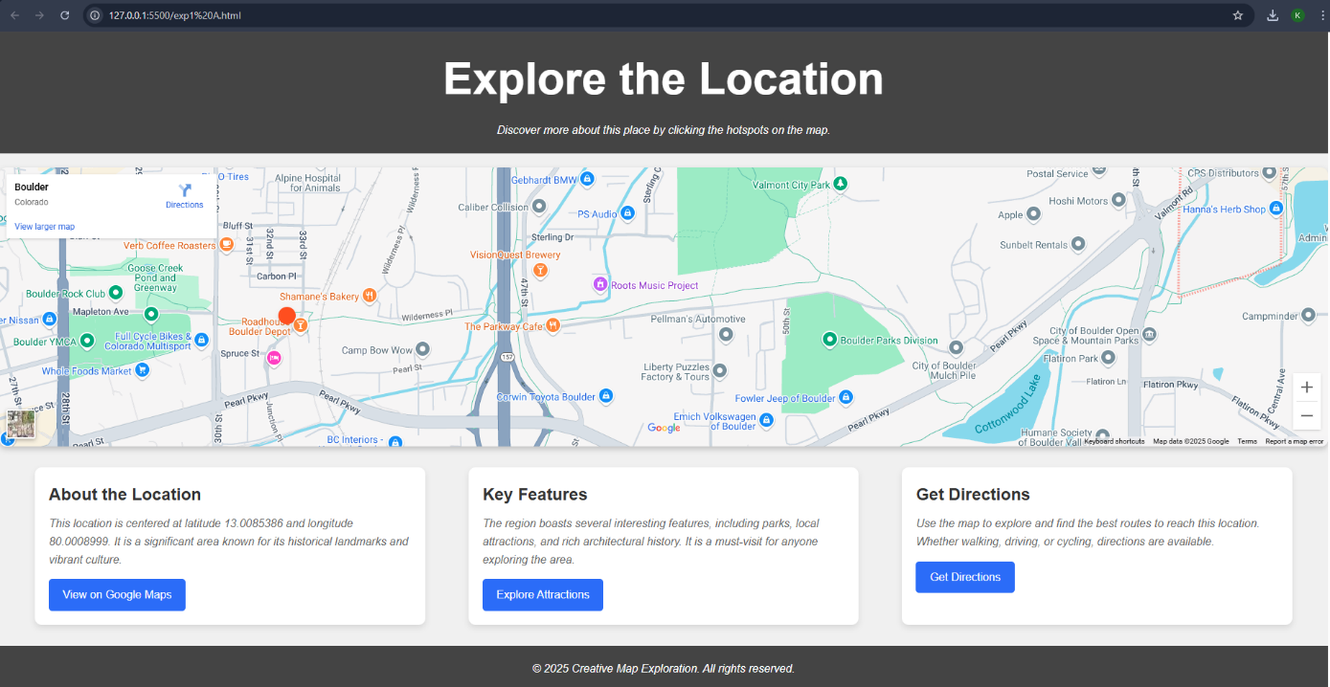

**RESULT :**

Thus the give task is executed successfully.

b) Create a web page using an embedded, external and inline CSS file.

**AIM:**

Demonstrate the use of inline, embedded, and external CSS to style a webpage with a clean and professional design.

**ALGORITHM:**

• Define the basic HTML structure with header, main content, and footer sections.

• Style the webpage with embedded CSS to design a clean, responsive layout.

• Divide the main content into three distinct sections: Web Development, Creative Design, and SEO Optimization.

• Add hover effects to the sections to enhance interactivity.

• Include relevant content for each section describing the services provided.

• Provide call-to-action buttons ("Learn More", "Explore Our Designs", "Boost Your Ranking") for user engagement.

• Add a footer with copyright information and a message.

• Test the webpage for responsiveness and interactivity across devices.

**CODE :**

<!DOCTYPE html>

<html lang="en">

<head>

<meta charset="UTF-8">

<meta name="viewport" content="width=device-width, initial-scale=1.0">

<title>Creative Web Design</title>

<style>

/* Embedded CSS */

body {

font-family: 'Arial', sans-serif;

margin: 0;

padding: 0;

background-color: #fafafa;

}

header {

background-color: #333;

color: white;

padding: 20px;

text-align: center;

}

/* External CSS can be linked as well - for demonstration, we'll include it inline */

.main-content {

display: flex;

justify-content: space-between;

margin: 20px;

gap: 20px;

}

.section {

background-color: #fff;

padding: 20px;

width: 30%;

box-shadow: 0 0 10px rgba(0, 0, 0, 0.1);

transition: transform 0.3s;

border-radius: 8px;

}

.section:hover {

transform: translateY(-10px);

}

.section h3 {

color: #333;

margin-bottom: 15px;

font-size: 1.5rem;

}

.section p {

font-size: 1rem;

color: #666;

margin-bottom: 20px;

}

.btn {

background-color: #007BFF;

color: white;

padding: 10px;

text-decoration: none;

border-radius: 5px;

display: inline-block;

}

.btn:hover {

background-color: #0056b3;

}

footer {

text-align: center;

padding: 20px;

background-color: #333;

color: white;

margin-top: 30px;

font-size: 1rem;

}

</style>

<link rel="stylesheet" href="styles.css"> <!-- External CSS file, assuming "styles.css" is available -->

</head>

<body>

<header>

<h1>Creative Web Design</h1>

<p>Discover cutting-edge web solutions that blend creativity and functionality.</p>

</header>

<div class="main-content">

<div class="section">

<h3>Web Development</h3>

<p>Our web development services are designed to help you build highly functional websites tailored to your business needs. We specialize in responsive design, seamless user experience, and fast-loading pages that drive engagement.</p>

<a href="#" class="btn">Learn More</a>

</div>

<div class="section" style="background-color: #f9f9f9;"> <!-- Inline CSS for this section -->

<h3>Creative Design</h3>

<p>Stand out with visually stunning and user-friendly designs. We combine aesthetics and purpose to create websites that captivate visitors and represent your brand identity effectively. From custom graphics to intuitive layouts, we ensure your website is both beautiful and functional.</p>

<a href="#" class="btn">Explore Our Designs</a>

</div>

<div class="section">

<h3>SEO Optimization</h3>

<p>Boost your website’s visibility with our comprehensive SEO optimization services. We help you improve your search engine rankings, driving organic traffic and enhancing your digital presence. Our strategies focus on both on-page and off-page SEO techniques to ensure long-term success.</p>

<a href="#" class="btn">Boost Your Ranking</a>

</div>

</div>

<footer>

<p>&copy; 2025 Creative Website. All rights reserved. | Designed with passion by the Creative Team</p>

</footer>

</body>

</html>

**OUTPUT:**

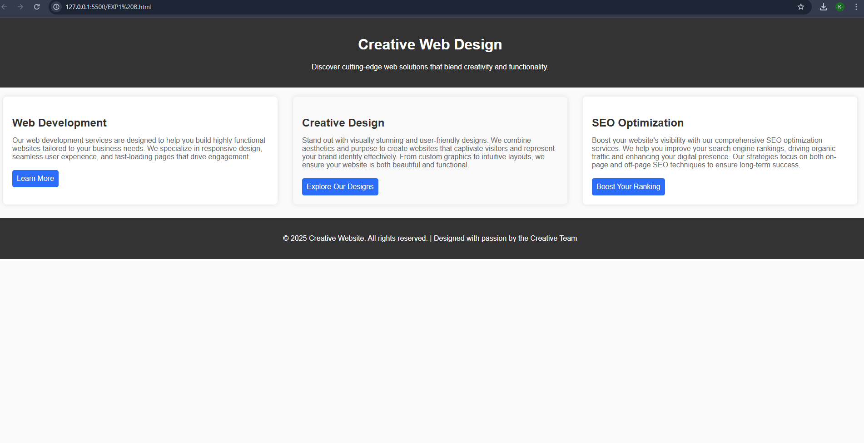

**RESULT:**

Thus the given task is executed successfully.